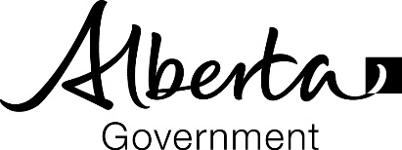
Alberta Education
2nd Floor, 44 Capital Boulevard
10044 – 108 Street
Edmonton, Alberta T5J 5E6
Canada
www.education.alberta.ca

{Processed Date}
Alberta Student Number: {StudentASN}
{Recipient Name}
{Recipient Address}

Congratulations {Preferred name}!
You have satisfied the requirements for the {Diploma / Certificate Name}.
The following information is required when communicating with Alberta Education, Advanced Education and post-secondary institutions:
- Alberta Student Number (ASN): {StudentASN}
- Legal Name: {Student Legal name}
- Date of Birth: {Date of Birth}
Your student information is available through myPass at myPass.alberta.ca.
myPass is an Alberta Education secure self-service website for you to:
• Order high school transcripts
• View diploma exam marks
• Register to write or rewrite diploma exams with online payment
• View and print Detailed Academic Reports (DAR)
• View progress towards a high school credential (diploma or certificate)
• View/update student personal information
• Order additional copies of an awarded credential in English or French
• Request diploma exam rescores
To obtain access to myPass, visit myPass.alberta.ca and follow the instructions provided.
If further credential information is required, please contact:

Alberta Education Transcripts and Diplomas
Hours of Operation: 8:15am to 4:30pm Monday – Friday (Mountain Time)
Phone: (780) 427-5732 (for toll free access within Alberta, first dial 310-0000)
Email: StudentRecords@gov.ab.ca

